XPLORE NEXUS
Integrated Event, Meeting, and Training Management Platform

Project Proposal
March 24, 2026

Prepared by:
Jose Louis D. Rosales
Full Stack Web Developer Intern

Department:
Xplore / Skillsoft

Organization:
Informatics Holdings Philippines, Inc.

1. Project Overview
Xplore Nexus is a centralized SaaS platform designed to streamline event management, meeting coordination, and training delivery within Informatics Holdings Philippines, Inc.
The current operational setup relies on multiple disconnected tools, resulting in inefficiencies, manual processes, and limited visibility across systems. These challenges impact productivity, data accuracy, and overall user experience.
This project proposes the development of a unified platform that integrates key operational components into a single system, including:
- Event creation and registration
- Video meetings and webinars (via Zoom integration)
- Skillsoft-based training modules
- Automated attendance tracking and analytics
By consolidating these functionalities, Xplore Nexus aims to eliminate fragmented workflows and provide a seamless, end-to-end user experience.
The platform is designed with a scalable architecture, allowing it to support both internal operations and future expansion into a revenue-generating SaaS solution.

2. Current Operational Challenges
The organization currently relies on multiple disconnected tools to manage event coordination and training delivery. This fragmented setup creates inefficiencies across workflows and limits overall system visibility.

2.1 Fragmented Scheduling Systems
Scheduling activities are handled across different platforms, including meeting tools, communication channels, and manual spreadsheets.
This results in:
- Lack of a centralized scheduling system
- Increased risk of miscommunication and overlapping events
- Time-consuming coordination across multiple tools

2.2 Manual Attendance Tracking
Attendance tracking for events and training sessions is currently performed manually.
This leads to:
- High administrative workload
- Increased likelihood of human error
- Delays in attendance validation and reporting

2.3 Disconnected Data Sources
Event-related data and training data are stored separately across different systems.
As a result:
- No unified view of user participation
- Manual data consolidation is required
- Limited visibility across platforms

2.4 Lack of Centralized Analytics
There is no centralized system for monitoring engagement and performance.
This limits the organization’s ability to:
- Track attendance and participation in real time
- Measure training effectiveness
- Generate data-driven insights for decision-making

2.5 Operational Impact
Due to the current setup, the organization experiences the following:
- Increased Administrative Workload
Manual processes consume time and reduce efficiency
- Inconsistent User Experience
Users must navigate multiple platforms for a single workflow
- Limited Visibility into Performance Metrics
Lack of centralized analytics restricts actionable insights

3. Objectives
The Xplore Nexus project aims to address the identified operational challenges by establishing a centralized and scalable system for managing events, meetings, and training.
The key objectives of the project are as follows:

3.1 Centralize Operations
To develop a unified platform that consolidates event management, meeting coordination, and training delivery into a single system.
This ensures:
- A single source of truth for all activities
- Improved coordination between teams
- Reduced dependency on multiple disconnected tools

3.2 Automate Attendance and Tracking
- To replace manual attendance processes with a fully digital system that enables:
- Automated event registration
- Real-time attendance tracking
- Accurate and reliable data recording

3.3 Enable Internal Testing and Validation
To implement the system initially within the organization, allowing:
- Controlled internal deployment
- Validation of workflows and features
- Identification and resolution of issues before external rollout

3.4 Establish a Scalable SaaS Foundation
To design the system with scalability in mind, enabling future expansion into:
- A subscription-based SaaS platform
- A revenue-generating solution
- A system capable of supporting larger user bases and external clients

3.5 Scope and Delimitation
The scope of Xplore Nexus focuses on delivering a functional and centralized platform for managing events, meetings, and training within the organization.
Included in Scope:
- Event creation, scheduling, and participant management
- User registration and attendance tracking
- Meeting coordination through Zoom integration
- Training module access and progress tracking
- Basic analytics and reporting dashboard
Excluded from Scope (Initial Phase):
- Full Learning Management System (LMS) replacement
- Advanced AI-driven analytics and recommendations
- Mobile application development (web-only focus)
- Large-scale external SaaS deployment
This ensures that the system remains focused, achievable within the internship duration, and aligned with core organizational needs.

4. Solution Overview
Xplore Nexus is designed as a unified digital platform that integrates event management, meeting coordination, and training delivery into a single system.
The solution addresses the limitations of the current fragmented setup by centralizing all core processes into one streamlined environment.

4.1 Unified Platform Approach
Instead of relying on multiple independent tools, Xplore Nexus consolidates key functionalities into a single platform, including:
- Event creation and management
- User registration and attendance tracking
- Video meetings and webinars through Zoom integration
- Training delivery via Skillsoft modules
- Centralized analytics and reporting
This approach eliminates the need for users and administrators to switch between different systems.

4.2 End-to-End Workflow Integration
The platform is designed to support the complete lifecycle of events and training:
- Users can discover events and training programs within a centralized dashboard
- Registration is handled within the platform, including optional payment processing
- Sessions are accessed directly through integrated meeting tools
- Attendance and participation data are automatically recorded and stored
This ensures a seamless experience from initial access to completion.

4.3 Centralized Data and Analytics
All user activities, event data, and training records are stored in a single system, enabling:
- Real-time tracking of attendance and engagement
- Consolidated reporting across events and training programs
- Improved visibility for administrators and decision-makers

4.4 Scalable and Modular Design
The system is built using a modular architecture, allowing it to:
- Scale as the number of users and events increases
- Support additional features and integrations in the future
- Transition from an internal tool to a full SaaS platform

4.5 Operational Benefits
By implementing Xplore Nexus, the organization can:
- Reduce manual administrative tasks
- Improve efficiency across workflows
- Provide a consistent and user-friendly experience
- Enable data-driven decision-making

5. Key Features
Xplore Nexus provides a comprehensive set of features designed to support event management, meeting coordination, and training delivery within a unified system.

5.1 Event Management
The platform enables administrators to efficiently create, organize, and manage events.
Key capabilities include:
- Event creation and scheduling
- Centralized event listings
- Participant registration and management
- Automated attendee tracking
This ensures a structured and organized approach to handling both onsite and online events.

5.2 Meetings and Webinars Integration
Xplore Nexus integrates video conferencing capabilities directly into the platform through Zoom API.
Key capabilities include:
- Embedded video meetings and webinars
- One-click session access within the system
- Calendar scheduling and automated notifications
- Seamless transition from registration to live session
This eliminates the need for external meeting links and improves user convenience.

5.3 Training Management
The system supports structured learning through integration with training platforms such as Skillsoft.
Key capabilities include:
- Access to training modules and courses
- Progress tracking and completion monitoring
- Certification generation upon completion
- Integration of training with scheduled events
This allows the organization to manage both events and learning on one platform.

5.4 Analytics and Reporting
Xplore Nexus provides centralized analytics to support monitoring and decision-making.
Key capabilities include:
- Real-time attendance tracking
- User participation and engagement metrics
- Consolidated reports across events and training
- Performance insights for administrators
This enables data-driven evaluation of programs and activities.

5.5 User Roles and Access Levels
Xplore Nexus implements a role-based access control (RBAC) system to ensure secure and organized system usage.
Defined Roles:
- Administrator
  - Full system access
  - Manage users, roles, and permissions
  - Approve events and monitor analytics
- Organizer / Staff
  - Create and manage events, meetings, and training
  - View participant data and reports
- User / Participant
  - Register for events and training
  - Join meetings and track progress
This structure ensures proper control, accountability, and security across the platform.

5.6 Functional & Non-Functional Requirements
The following tables define the system's functional and non-functional requirements derived from the feature set and user workflows described above. These requirements serve as the reference baseline for development, testing, and acceptance.

5.6.1 Functional Requirements

ID | Module | Requirement | Priority | Role
FR-001 | Auth | Users must be able to register with email and password | Must Have | All
FR-002 | Auth | Users must be able to log in securely using JWT-based authentication | Must Have | All
FR-003 | Auth | Admins must be able to assign roles (Admin, Organizer, User) to accounts | Must Have | Admin
FR-004 | Auth | System must support password reset via email link | Must Have | All
FR-005 | Events | Organizers must be able to create events with title, type, date/time, location, and participant limit | Must Have | Organizer, Admin
FR-006 | Events | Organizers must be able to edit and delete events they created | Must Have | Organizer, Admin
FR-007 | Events | Users must be able to browse and register for available events | Must Have | User
FR-008 | Events | System must automatically track and log attendance for events | Must Have | System
FR-009 | Events | System must send automated confirmation emails upon successful registration | Must Have | System
FR-010 | Events | Admins must be able to view participant lists for any event | Must Have | Admin
FR-011 | Events | Events must support both online and onsite types | Must Have | Organizer
FR-012 | Events | Paid events must support payment processing before confirming registration | Should Have | User
FR-013 | Meetings | Organizers must be able to schedule meetings with title, date/time, and duration | Must Have | Organizer, Admin
FR-014 | Meetings | System must generate a Zoom meeting link via Zoom API upon scheduling | Must Have | System
FR-015 | Meetings | Users must be able to join live meetings directly from the platform | Must Have | User
FR-016 | Meetings | Meetings must display status: Live, Upcoming, or Completed | Must Have | All
FR-017 | Meetings | System must support recurring meetings | Nice to Have | Organizer
FR-018 | Training | Admins/Organizers must be able to create training programs with modules | Must Have | Admin, Organizer
FR-019 | Training | Users must be able to enroll in training programs and track progress | Must Have | User
FR-020 | Training | System must display a progress bar per training course per user | Must Have | User
FR-021 | Training | System must automatically generate and issue a certificate upon course completion | Must Have | System
FR-022 | Training | Instructors must be able to view analytics for their training programs | Should Have | Organizer, Admin
FR-023 | Analytics | Admins must view total events, active trainings, attendance rate, and engagement score on the dashboard | Must Have | Admin
FR-024 | Analytics | System must display attendance trend charts over configurable time periods | Must Have | Admin
FR-025 | Analytics | System must generate consolidated reports exportable as PDF or CSV | Should Have | Admin
FR-026 | Users | Admins must be able to view, add, edit, and deactivate user accounts | Must Have | Admin
FR-027 | Users | Users must be able to edit their own profile (name, email, phone, avatar) | Must Have | All
FR-028 | Notifications | System must send in-app and email notifications for key events (registration, reminders, completions) | Must Have | System
FR-029 | Settings | Users must be able to manage notification preferences | Should Have | All
FR-030 | Settings | Admins must be able to configure organization-level settings | Should Have | Admin
FR-031 | Payments | System must integrate PayMongo or Stripe for processing paid event registrations | Should Have | System
FR-032 | Payments | System must generate a receipt/invoice after successful payment | Should Have | System

5.6.2 Non-Functional Requirements

ID | Category | Requirement | Target / Metric | Priority
NFR-001 | Performance | Pages must load within acceptable time on standard connection | < 3 seconds initial load | Must Have
NFR-002 | Performance | Dashboard analytics must reflect real-time data with minimal delay | < 5 seconds refresh | Must Have
NFR-003 | Scalability | System must support concurrent users without performance degradation | Up to 500 concurrent users (MVP) | Must Have
NFR-004 | Scalability | Database and hosting must support horizontal scaling as user base grows | Supabase / Vercel auto-scale | Should Have
NFR-005 | Security | All data transmission must be encrypted | HTTPS / TLS enforced | Must Have
NFR-006 | Security | User passwords must be hashed before storage | bcrypt (salt rounds >= 10) | Must Have
NFR-007 | Security | All API endpoints must require authentication except public routes | JWT Bearer token | Must Have
NFR-008 | Security | System must implement RBAC to restrict access based on user role | Admin / Organizer / User roles | Must Have
NFR-009 | Security | System must protect against common vulnerabilities | OWASP Top 10 (SQL injection, XSS, CSRF) | Must Have
NFR-010 | Availability | System must maintain high uptime during business hours | >= 99% uptime (Vercel SLA) | Must Have
NFR-011 | Usability | UI must be responsive and functional across common screen sizes | Desktop, tablet, mobile | Must Have
NFR-012 | Usability | UI must follow a consistent design system with accessible color contrast | WCAG AA compliance (target) | Should Have
NFR-013 | Maintainability | Codebase must follow modular component architecture for easy updates | Next.js App Router + TypeScript | Must Have
NFR-014 | Maintainability | All API routes must be documented during development | Inline JSDoc comments / OpenAPI | Should Have
NFR-015 | Compatibility | System must function correctly on major modern browsers | Chrome, Edge, Firefox, Safari | Must Have
NFR-016 | Reliability | System must handle API failures from Zoom/Payment gateways gracefully | User-facing error messages, no crashes | Must Have
NFR-017 | Reliability | System must implement retry logic for critical external API calls | Exponential backoff (Zoom, payment) | Should Have
NFR-018 | Data Integrity | All form inputs must be validated on both client and server side | Zod schema validation | Must Have
NFR-019 | Compliance | User data must be handled in accordance with data privacy standards | RA 10173 / GDPR principles | Must Have
NFR-020 | Deployment | System must support separate development, staging, and production environments | Vercel preview deployments | Should Have

5.7 User Stories & Acceptance Criteria
The following user stories define the expected system behaviors from each role's perspective and serve as the basis for sprint planning and acceptance testing.
ID | Role | User Story | Acceptance Criteria
US-001 | Organizer | As an Organizer, I want to create an event so that participants can register. | Given I am logged in as Organizer, when I fill in event details and click Create, then the event appears in the list with status Upcoming.
US-002 | User | As a User, I want to register for an event so that I can attend it. | Given an event exists, when I click Register, then I receive a confirmation email and the event appears in My Events.
US-003 | User | As a User, I want to join a live meeting from the platform so I do not need external links. | Given a meeting is Live, when I click Join Now, then I am directed into the Zoom session within the platform.
US-004 | User | As a User, I want to track my training progress so I know how much is left. | Given I am enrolled in a training, when I view it, then a progress bar reflects my completed modules.
US-005 | System | As the System, I want to issue a certificate upon training completion automatically. | Given a user completes all modules, then a certificate PDF is generated and available in their profile.
US-006 | Admin | As an Admin, I want to manage user roles so I can control platform access. | Given I am logged in as Admin, when I assign a role to a user, then their permissions update immediately.
US-007 | Admin | As an Admin, I want to view consolidated analytics so I can track platform engagement. | Given I navigate to Analytics, then I see attendance trends, event counts, and engagement scores updated in real time.

5.8 Notification System Design
The platform will deliver two types of notifications to keep users informed of relevant activity:
In-App Notifications — displayed in the header bell icon inside the platform.
Email Notifications — sent automatically by the system via transactional email (Resend or SendGrid).
Trigger Event | Channel | Recipient
Successful event registration | Email + In-App | Registrant
Session starting in 1 hour | Email + In-App | Registered Users
Session starting in 15 minutes | In-App | Registered Users
Meeting scheduled by Organizer | Email | Invited Participants
Training enrollment confirmed | Email + In-App | Enrollee
Training module completed | In-App | Enrollee
Training course 100% completed + cert | Email + In-App | Enrollee
Payment successful | Email | Payer
New user account created (by Admin) | Email | New User
Role changed by Admin | In-App | Affected User

6. Feature Comparison
To better understand the value of Xplore Nexus, it is important to compare it with existing platforms currently used for event management, meetings, and training.
Most organizations rely on separate tools for each function, which leads to fragmented workflows and disconnected data.
Xplore Nexus addresses this by combining these capabilities into a single, unified platform.

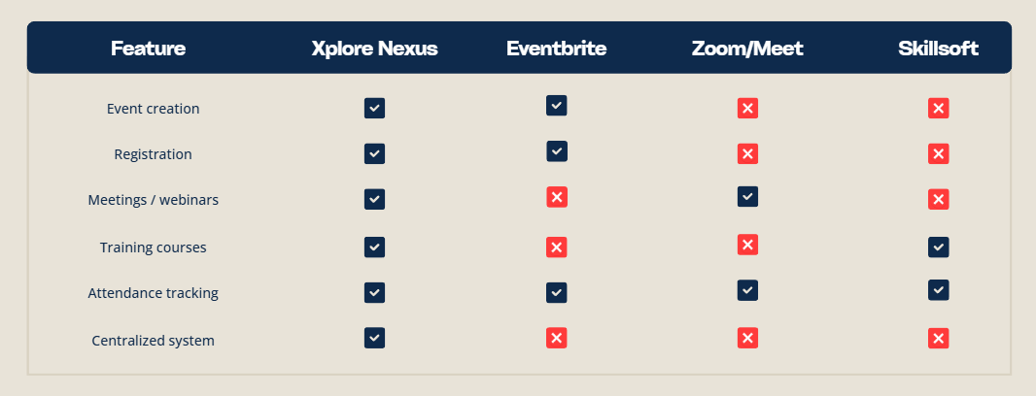

6.1 Key Insights
- Existing platforms are specialized but isolated, meaning each tool handles only one function
- Organizations must switch between systems, leading to inefficiencies and data fragmentation
- Analytics are either limited or separated across platforms

6.2 Competitive Advantage of Xplore Nexus
Xplore Nexus provides a distinct advantage by:
- Integrating event management, meetings, and training into one system
- Eliminating the need for multiple tools
- Centralizing all user data and analytics
- Automating processes such as registration and attendance tracking

7. User Workflow and Customer Journey
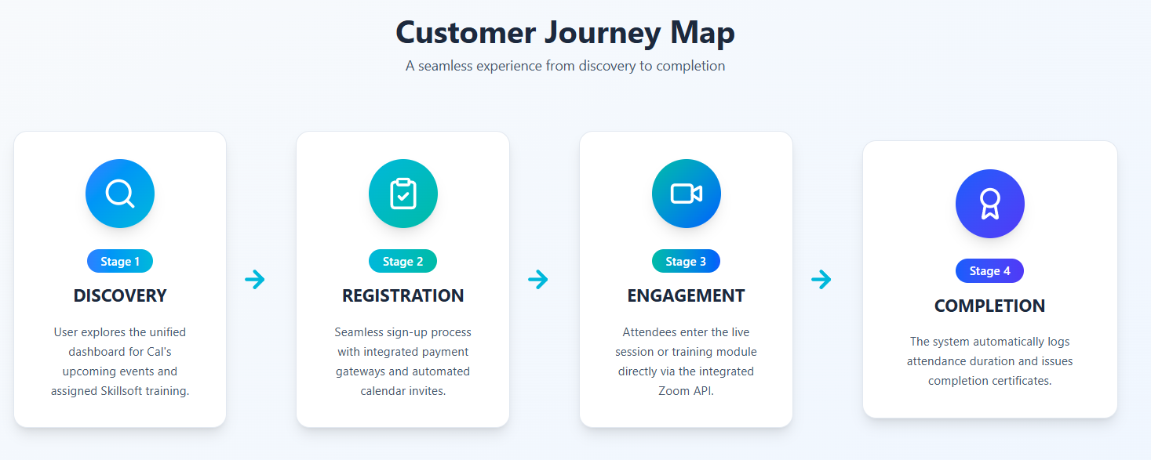
Xplore Nexus is designed to provide a seamless and structured user experience by integrating event participation and training workflows into a single platform.
The system follows a simplified end-to-end process that eliminates the need for users to switch between multiple tools.

7.1 Step 1: Access and Discovery
Users access the centralized platform through a web interface, where they are presented with a unified dashboard.
The dashboard displays:
- Upcoming events (onsite and online)
- Available training modules
- Relevant schedules and announcements
This provides users with a single entry point for all activities.

7.2 Step 2: Registration and Enrollment
Users can select an event or training program and complete the registration process within the platform.
Key actions include:
- Submitting registration details
- Processing payments (if applicable)
- Receiving automated confirmation and calendar invites
This removes the need for external registration systems.

7.3 Step 3: Session Participation
On the scheduled date, users can join sessions directly from the platform.
Key features:
- One-click access to meetings or webinars
- Integrated Zoom interface
- No need to switch applications or open external links
This ensures a smooth transition from registration to participation.

7.4 Step 4: Completion and Tracking
After the session, the system automatically records user activity and updates relevant data.
Key outputs include:
- Attendance logging
- Completion tracking for training
- Generation of certificates (if applicable)
- Real-time updates to analytics dashboards
This eliminates manual tracking and ensures accurate data collection.

8. Technical Architecture
Xplore Nexus is built using a modern, scalable, and modular architecture to ensure performance, flexibility, and long-term maintainability.
The system follows a web-based architecture that integrates frontend interfaces, backend services, and external APIs into a unified platform.
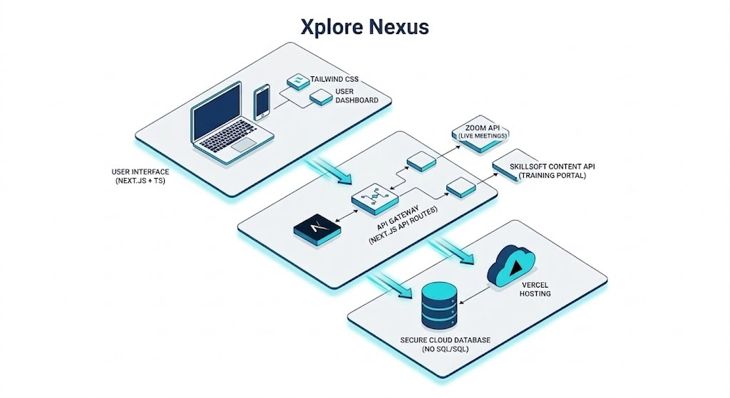

8.1 Development Approach
The project follows an Agile development methodology, allowing iterative progress and continuous improvement.
Key principles include:
- Incremental feature development
- Continuous testing and feedback
- Rapid prototyping before full implementation
This ensures the system evolves based on actual user and stakeholder needs.

8.2 Technology Stack
The platform utilizes a modern development stack to ensure efficiency and scalability:
- Frontend: Next.js (TypeScript)
Enables fast rendering, structured routing, and maintainable code
- UI Framework: Tailwind CSS
Provides responsive and consistent user interface design
- Database: Supabase (PostgreSQL) — selected for built-in auth, real-time subscriptions, and seamless Next.js integration
Supports scalable and secure data storage
- Core Integrations:
  - Zoom API (Meeting SDK) for video sessions
  - Payment Gateway (PayMongo / Stripe) for transaction processing

8.3 System Architecture Overview
The system is structured into three main layers:
- Frontend Layer
Handles user interface, dashboards, and user interactions
- Backend Layer
Manages business logic, authentication, and data processing
- Integration Layer
Connects external services such as Zoom and payment gateways
This layered approach ensures separation of concerns and easier system maintenance.

8.4 System Design Principles
The architecture is designed based on the following principles:
- Modular Design
Features are separated into components for easier updates and scalability
- API-Driven Integration
External services are connected through secure APIs
- Scalability
System can handle increasing users and data without major restructuring
- Security
Authentication and data handling follow standard security practices

8.5 Deployment Architecture
The system is deployed using a cloud-based architecture to ensure accessibility and scalability.
- Frontend Hosting
  - Deployed via Vercel for fast and reliable delivery
- Backend Services
  - Hosted on cloud platforms or serverless environments
- Database
  - Managed through Supabase (PostgreSQL)
- External Integrations
  - Zoom API for meetings
  - Payment gateway for transactions
This setup ensures efficient system performance and scalability.

8.6 API Design Overview
The system follows an API-driven architecture to enable communication between frontend, backend, and external services.
General Flow:
User → Frontend Interface → Backend API → Database / External API → Response to User
Example (Meeting Creation Flow):
- User schedules a meeting via frontend
- Frontend sends request to backend API
- Backend processes request and calls Zoom API
- Zoom API returns meeting details
- Backend stores data and returns response to frontend
This architecture ensures modularity, scalability, and seamless integration with external services.

8.6.1 Database Design / Schema
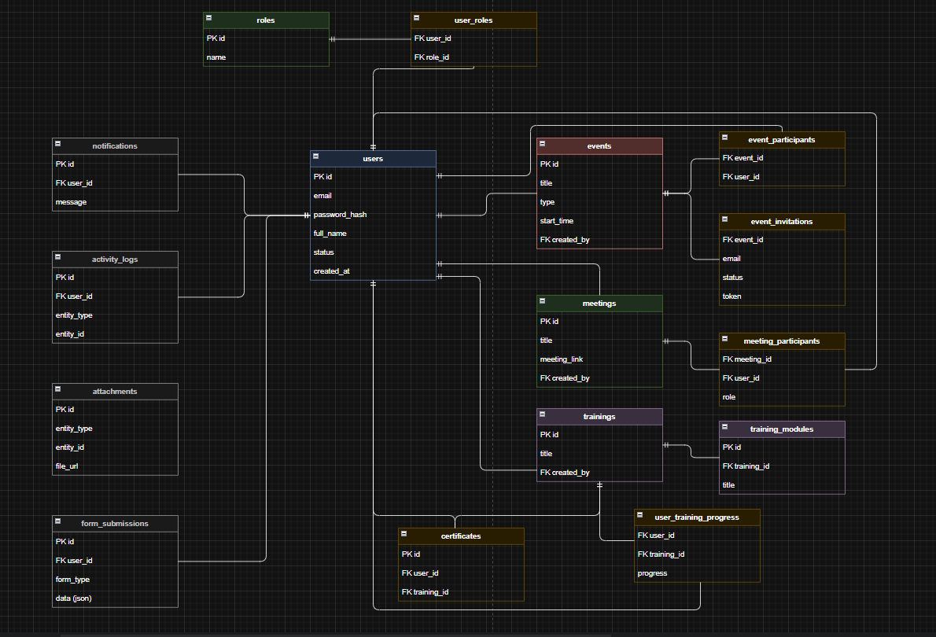

Table | Columns
users | id (PK), email (unique), password_hash, full_name, status, created_at
roles | id (PK), name
user_roles | user_id (FK → users.id), role_id (FK → roles.id)

Table | Columns
events | id (PK), title, type, start_time, created_by (FK → users.id)
event_participants | event_id (FK → events.id), user_id (FK → users.id)
event_invitations | event_id (FK → events.id), email, status, token

Table | Columns
meetings | id (PK), title, meeting_link, created_by (FK → users.id)
meeting_participants | meeting_id (FK → meetings.id), user_id (FK → users.id), role

Table | Columns
trainings | id (PK), title, created_by (FK → users.id)
training_modules | id (PK), training_id (FK → trainings.id), title
user_training_progress | user_id (FK → users.id), training_id (FK → trainings.id), progress
certificates | id (PK), user_id (FK → users.id), training_id (FK → trainings.id)

Table | Columns

Table: users
Column | Type | Notes
id | UUID | Primary key (auto-generated)
email | VARCHAR | Unique, required
password_hash | TEXT | bcrypt hashed
full_name | VARCHAR
role | ENUM | admin | organizer | user
avatar_url | TEXT | Profile photo URL — ADDED
phone | VARCHAR | Optional — ADDED
department | VARCHAR | User's department — ADDED
organization_id | UUID FK | For multi-tenant support — ADDED
status | ENUM | active | inactive
created_at | TIMESTAMP
updated_at | TIMESTAMP

Table: events
Column | Type | Notes
id | UUID | Primary key
title | VARCHAR
description | TEXT | ADDED
type | ENUM | online | onsite
location | VARCHAR | Physical address or 'Online' — ADDED
start_time | TIMESTAMP
end_time | TIMESTAMP | ADDED
max_participants | INTEGER | Capacity limit — ADDED
organizer_id | UUID FK | References users.id
status | ENUM | upcoming | live | completed | cancelled — ADDED
is_paid | BOOLEAN | ADDED
price | DECIMAL | 0.00 if free — ADDED
created_at | TIMESTAMP

Table: meetings
Column | Type | Notes
id | UUID | Primary key
title | VARCHAR
host_id | UUID FK | References users.id
zoom_meeting_id | VARCHAR | From Zoom API — ADDED
zoom_join_url | TEXT | Meeting join link
start_time | TIMESTAMP | ADDED
end_time | TIMESTAMP | ADDED
duration_min | INTEGER | Duration in minutes
max_participants | INTEGER | ADDED
status | ENUM | upcoming | live | completed — ADDED
created_at | TIMESTAMP

Table: trainings
Column | Type | Notes
id | UUID | Primary key
title | VARCHAR
description | TEXT | ADDED
category | VARCHAR | e.g. Leadership, Tech — ADDED
instructor_id | UUID FK | References users.id
thumbnail_url | TEXT | Course cover image — ADDED
duration_hours | DECIMAL | Estimated total hours — ADDED
status | ENUM | draft | published | archived — ADDED
created_at | TIMESTAMP
The system begins with the landing page and authentication module, which directs users to the main dashboard upon successful login. From the dashboard, users can access core functionalities such as event management, meeting scheduling, training management, user administration, reporting, and system settings. Each module contains sub-features that support specific user tasks, ensuring efficient navigation and usability.

Table: certificates
Column | Type | Notes
id | UUID | Primary key
user_id | UUID FK | References users.id
training_id | UUID FK | References trainings.id
issued_at | TIMESTAMP | ADDED
certificate_url | TEXT | PDF download URL — ADDED
expiry_date | DATE | Optional — ADDED

Table: user_training_progress
Column | Type | Notes
id | UUID | Primary key
user_id | UUID FK | References users.id
training_id | UUID FK | References trainings.id
progress_percent | INTEGER | 0–100
status | ENUM | enrolled | in_progress | completed — ADDED
completed_at | TIMESTAMP | NULL until completed — ADDED
last_accessed_at | TIMESTAMP | ADDED

Table: payments
Column | Type | Notes
id | UUID | Primary key
user_id | UUID FK | References users.id
event_id | UUID FK | References events.id
amount | DECIMAL | Amount charged
currency | VARCHAR | Default: PHP
status | ENUM | pending | paid | failed | refunded
provider | ENUM | paymongo | stripe
reference_id | VARCHAR | External provider transaction ID
paid_at | TIMESTAMP | NULL until confirmed
created_at | TIMESTAMP
│

Table: notifications
Column | Type | Notes
id | UUID | Primary key
user_id | UUID FK | References users.id
title | VARCHAR | Short notification title
message | TEXT | Notification body
is_read | BOOLEAN | Default: false
type | VARCHAR | e.g. event_reminder, cert_issued
created_at | TIMESTAMP

Table: organizations
Column | Type | Notes
id | UUID | Primary key
name | VARCHAR | Organization name
slug | VARCHAR | Unique URL-safe identifier
logo_url | TEXT | Optional
plan | ENUM | free | pro | enterprise
created_at | TIMESTAMP

8.7 Site Map of Nexus Xplore
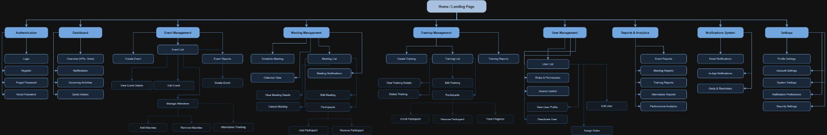
The site map illustrates the overall structure and navigation flow of the Nexus Xplore system. It presents how different modules and pages are organized and interconnected, providing a clear view of how users interact with the platform.

Home / Landing Page
│
├── Authentication
│ ├── Login
│ ├── Register
│ ├── Forgot Password
│ └── Reset Password
│
├── Dashboard
│ ├── Overview (KPIs, Stats)
│ ├── Notifications
│ ├── Upcoming Activities
│ └── Quick Actions
│
├── Event Management
│ ├── Create Event
│ ├── Event List
│ │ ├── View Event Details
│ │ ├── Edit Event
│ │ ├── Delete Event
│ │ └── Manage Attendees
│ │ ├── Add Attendee
│ │ ├── Remove Attendee
│ │ └── Attendance Tracking
│ └── Event Reports
│
├── Meeting Management
│ ├── Schedule Meeting
│ ├── Calendar View
│ ├── Meeting List
│ │ ├── View Meeting Details
│ │ ├── Edit Meeting
│ │ ├── Cancel Meeting
│ │ └── Participants
│ │ ├── Add Participant
│ │ └── Remove Participant
│ └── Meeting Notifications
│
├── Training Management
│ ├── Create Training
│ ├── Training List
│ │ ├── View Training Details
│ │ ├── Edit Training
│ │ ├── Delete Training
│ │ └── Participants
│ │ ├── Enroll Participant
│ │ ├── Remove Participant
│ │ └── Progress Tracking
│ ├── Training Modules
│ │ ├── Add Module
│ │ ├── Edit Module
│ │ └── Delete Module
│ ├── Certificate Management
│ │ ├── Issue Certificate
│ │ └── View / Download Certificate
│ └── Training Reports
│
├── Analytics & Reporting
│ ├── Overview Dashboard
│ │ ├── Attendance Rate
│ │ ├── Engagement Score
│ │ ├── Total Events
│ │ └── Active Trainings
│ ├── Event Analytics
│ ├── Meeting Analytics
│ ├── Training Analytics
│ └── Export Reports
│ ├── Export as PDF
│ └── Export as CSV
│
├── User Management
│ ├── User List
│ │ ├── View User Profile
│ │ ├── Edit User
│ │ ├── Assign Role
│ │ └── Deactivate / Activate User
│ └── Invite User
│
├── Notifications
│ ├── Notification List
│ │ ├── Mark as Read
│ │ └── Delete Notification
│ └── Notification Preferences
│
└── Settings
├── Profile Settings
│ ├── Edit Personal Info
│ ├── Change Password
│ └── Upload Avatar
├── Organization Settings
├── Notification Settings
├── Security Settings
└── Integrations
├── Zoom API
└── Payment Gateway (PayMongo / Stripe)

8.7 Authentication & Authorization Flow
The platform uses Supabase Auth (built on GoTrue) combined with JWT-based session management. The following describes the complete authentication and access control flow:
Login Method: Email and password. OAuth (Google) may be added as a future enhancement.
Registration: Invite-only for Organizers and Admins. Standard users can self-register via the public signup page.
Session Strategy: Supabase issues a JWT access token (1-hour expiry) and a refresh token (7-day expiry stored in an HttpOnly cookie). The client refreshes silently before expiry.
Password Reset: User requests reset via email. Supabase sends a one-time link valid for 24 hours. On click, user sets a new password.
Admin Account Setup: The first Admin account is seeded directly in Supabase. Subsequent Admins are created by an existing Admin through the Users Management module.
RBAC Enforcement: Role is stored in the users table and injected into the JWT claims. All Next.js API routes validate the role claim. Supabase Row-Level Security (RLS) policies provide a second enforcement layer at the database level.
Public Routes: POST /api/auth/login, POST /api/auth/register, GET /api/events (browse only). All other routes require a valid JWT Bearer token.

8.8 API Endpoint Reference (Draft)
The following table lists the planned REST API endpoints. This is a living reference — additional endpoints will be added during development. All protected routes require the Authorization: Bearer <token> header.
Method | Route | Description | Auth Required
POST | /api/auth/register | Register a new user account | No
POST | /api/auth/login | Log in and receive JWT + refresh token | No
POST | /api/auth/logout | Invalidate session | Yes
POST | /api/auth/reset-password | Request password reset email | No
GET | /api/events | List all upcoming events | No
POST | /api/events | Create a new event | Yes (Organizer/Admin)
GET | /api/events/:id | Get event details | No
PUT | /api/events/:id | Update an event | Yes (Organizer/Admin)
DELETE | /api/events/:id | Delete an event | Yes (Admin)
POST | /api/events/:id/register | Register current user for an event | Yes
GET | /api/events/:id/participants | List event participants | Yes (Admin/Organizer)
GET | /api/meetings | List all meetings | Yes
POST | /api/meetings | Schedule a new Zoom meeting | Yes (Organizer/Admin)
GET | /api/meetings/:id | Get meeting details + Zoom join URL | Yes
DELETE | /api/meetings/:id | Cancel a meeting | Yes (Admin)
GET | /api/trainings | List all published trainings | Yes
POST | /api/trainings | Create a training program | Yes (Admin/Organizer)
GET | /api/trainings/:id | Get training program details | Yes
POST | /api/trainings/:id/enroll | Enroll current user in a training | Yes
PUT | /api/trainings/:id/progress | Update user progress in a training | Yes
GET | /api/users | List all users | Yes (Admin)
GET | /api/users/:id | Get user profile | Yes
PUT | /api/users/:id | Update user profile or role | Yes
GET | /api/analytics/summary | Get dashboard metrics summary | Yes (Admin)
GET | /api/notifications | Get current user's notifications | Yes
PUT | /api/notifications/:id/read | Mark notification as read | Yes
POST | /api/payments/initiate | Initiate a payment for a paid event | Yes
POST | /api/payments/webhook | Handle PayMongo/Stripe webhook callback | No (verified by signature)
│ │ └── Track Progress

8.9 Environment Variables Reference
The following environment variables must be configured in a .env.local file for local development and in the Vercel project settings for production. Never commit secret values to the repository.
Variable | Description | Example / Source
NEXT_PUBLIC_SUPABASE_URL | Supabase project URL | https://xxxx.supabase.co
NEXT_PUBLIC_SUPABASE_ANON_KEY | Supabase public anon key | Supabase dashboard > API Keys
SUPABASE_SERVICE_ROLE_KEY | Supabase service role key (server-only) | Supabase dashboard > API Keys
ZOOM_SDK_KEY | Zoom Meeting SDK API key | Zoom Marketplace app credentials
ZOOM_SDK_SECRET | Zoom Meeting SDK secret | Zoom Marketplace app credentials
ZOOM_ACCOUNT_ID | Zoom Server-to-Server OAuth account ID | Zoom Marketplace
ZOOM_CLIENT_ID | Zoom OAuth client ID | Zoom Marketplace
ZOOM_CLIENT_SECRET | Zoom OAuth client secret | Zoom Marketplace
PAYMONGO_SECRET_KEY | PayMongo secret key for server API calls | PayMongo dashboard
PAYMONGO_PUBLIC_KEY | PayMongo public key for client-side | PayMongo dashboard
PAYMONGO_WEBHOOK_SECRET | PayMongo webhook signing secret | PayMongo dashboard > Webhooks
RESEND_API_KEY | Resend email API key for transactional mail | Resend dashboard
NEXT_PUBLIC_APP_URL | Base URL of the deployed application | https://xplorenexus.vercel.app
NEXTAUTH_SECRET | Secret for signing NextAuth sessions | Generate: openssl rand -base64 32

8.10 CI/CD and Branching Strategy
The project follows a trunk-based Git workflow with feature branches and Vercel preview deployments.
Branch | Purpose | Auto-Deploy Target
main | Production-ready code only. Protected branch — requires PR approval. | Production (xplorenexus.vercel.app)
develop | Integration branch for tested features before merging to main. | Staging (xplorenexus-dev.vercel.app)
feature/<name> | Feature-specific branches (e.g. feature/event-registration). | Preview URL (unique per PR)
fix/<name> | Bug fix branches. | Preview URL (unique per PR)
│
Deployment is triggered automatically by Vercel on every push. Production deploys only trigger on merge to main via approved Pull Request.

8.11 Payment Flow
For paid events, the payment flow is as follows. The primary payment gateway is PayMongo (Philippines-based); Stripe is the alternative for international users:
Step 1 — User Initiates Registration: User clicks Register on a paid event. The frontend calls POST /api/payments/initiate with the event_id.
Step 2 — Payment Intent Created: The server creates a payment intent via the PayMongo API and returns a checkout URL.
Step 3 — User Completes Payment: User is redirected to the PayMongo-hosted checkout page. They enter payment details.
Step 4 — Webhook Confirmation: PayMongo calls POST /api/payments/webhook. The server verifies the signature and marks payment status as paid.
Step 5 — Registration Confirmed: The event registration record is created. A confirmation email with receipt is sent to the user.
Step 6 — Failure Handling: If payment fails, the user is redirected back with an error. The payment record status is set to failed. No registration is created.
Refunds: Refunds must be initiated manually by an Admin through the PayMongo dashboard for the MVP phase. Automated refund flow is a future enhancement.
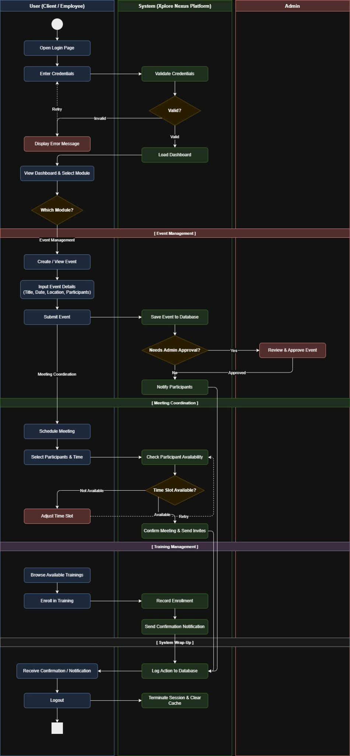
8.8 Activity Diagram


The Xplore Nexus Activity Diagram demonstrates a well-structured, role-based workflow that ensures proper authentication, seamless module navigation, optional administrative oversight, and consistent system logging. The use of decision nodes for credential validation, admin approval, and availability checking ensures that the system handles both ideal and exception paths appropriately, making the platform reliable and user-responsive.
Authentication
● START
↓
[Open Login Page]
↓
[Enter Credentials]
↓
[Validate Credentials] ← (System)
↓
◇ Valid?
├── ✗ Invalid ──→ [Display Error Message] ──→ (back to Enter Credentials)
└── ✓ Valid ──→ [Load Dashboard] ← (System)
↓
[View Dashboard & Select Module]
↓
◇ Which Module?
├── Event Management ──────────────────┐
├── Meeting Coordination ──────────────┤
└── Training Management ───────────────┤

Event Management Flow
[Create / View Event] │
↓ │
[Input Event Details] │
(Title, Date, Location, Participants) │
↓ │
[Submit Event] │
↓ │
[Save Event to Database] ← (System) │
↓ │
◇ Needs Admin Approval? │
├── Yes ──→ [Review & Approve Event] ← (Admin) │
│ ↓ Approved │
└── No ──→ [Notify Participants] ← (System) │
↓ │
[Log Action to Database] ←───────────────────┘

Meeting Coordination Flow
[Schedule Meeting] │
↓ │
[Select Participants & Time] │
↓ │
[Check Participant Availability] ← (System) │
↓ │
◇ Time Slot Available? │
├── Not Available ──→ [Adjust Time Slot] ──→ (back to Check Availability)
└── Available ──→ [Confirm Meeting & Send Invites] ← (System)
↓ │
[Log Action to Database] ←────────────┘
Training Management Flow
[Browse Available Trainings] │
↓ │
[Enroll in Training] │
↓ │
[Record Enrollment] ← (System) │
↓ │
[Send Confirmation Notification] ← (System) │
↓ │
[Log Action to Database] ←──────────────────────────────────┘

9. Development Roadmap (Internship Scope)
- This section outlines the development plan of Xplore Nexus aligned with the internship duration, which runs until June 2026.
- Given the limited timeframe, the project focuses on delivering a functional prototype rather than a full production-ready system.

9.1 Development Scope
The project prioritizes the following key areas:
- System planning and requirement validation
- UI/UX prototyping using Figma
- Core frontend development (Next.js)
- Initial backend and database integration
- Basic API integration (Zoom and/or payment, if feasible)

9.2 Development Approach
The system will be developed using an iterative approach:
Plan → Design → Develop → Test → Improve
Each phase builds on the previous one, allowing continuous refinement based on feedback and testing.

9.3 Development Timeline
Below is the planned timeline structured on a weekly basis:
Week | Dates | Focus | Key Activities | Expected Output
Week 1 | Mar 24 – Mar 28 | Planning | Project briefing, requirements gathering | Defined scope
Week 2 | Mar 30 – Apr 1 | System Design | Workflow mapping, architecture planning | System flow & structure
— | Apr 2 – Apr 5 | — | Holy Week (No Work) | —
Week 3 | Apr 6 – Apr 11 | Prototyping | Wireframes, dashboard design | Initial UI design
Week 4 | Apr 13 – Apr 18 | UI Finalization | Design refinement, feedback | Final UI/UX
Week 5 | Apr 20 – Apr 25 | Setup | Project setup, routing, structure | Base system
Week 6 | Apr 27 – May 2 | Frontend | UI implementation | Functional screens
Week 7 | May 4 – May 9 | Backend | Database setup, basic logic | Data handling
Week 8 | May 11 – May 16 | Features | Registration, event modules | Core features
Week 9 | May 18 – May 23 | Integration | Zoom API integration | Meeting feature
Week 10 | May 25 – May 30 | Integration | Payment integration (optional) | Payment-ready
Week 11 | Jun 1 – Jun 6 | Testing | Bug fixes, improvements | Stable build
Week 12 | Jun 8 – Jun 13 | Finalization | Optimization, documentation | Final prototype
Week 13 | Jun 15 – Jun 20 | Handover | Documentation, turnover | Completed project

9.4 Expected Deliverables
By the end of the internship, the project aims to deliver:
- A working prototype of the Xplore Nexus platform
- Core features including event management and basic integrations
- UI/UX designs and system architecture documentation
- Technical documentation for system handover

9.5 Project Limitations
Due to time constraints, the following are acknowledged:
- Full production deployment may not be completed
- Some advanced integrations may remain partial or in testing phase
- Focus is placed on core functionality rather than full feature completion

9.6 Project Risks and Mitigation
The project may encounter the following risks:
- API Dependency Risk
  - External services (e.g., Zoom) may experience downtime
  - Mitigation: Implement fallback handling and error responses
- Time Constraint
  - Limited development time during internship
  - Mitigation: Focus on MVP and prioritize core features
- Data Security Risks
  - Potential vulnerabilities in data handling
  - Mitigation: Implement secure authentication and validation

10. Cost-Effective Benefits
Xplore Nexus is designed to deliver operational improvements while minimizing costs by leveraging open-source technologies, existing company resources, and scalable cloud infrastructure.
The approach ensures that the system provides value without requiring significant upfront investment.

10.1 Reduced Development Costs
The system is developed in-house using modern open-source frameworks:
- Next.js (frontend framework)
- Tailwind CSS (UI framework)
This eliminates licensing fees and reduces overall development expenses.

10.2 Low-Cost Infrastructure Setup
During the initial phase, the platform utilizes free-tier cloud services:
- Hosting: Vercel (or equivalent)
- Database: Supabase / MongoDB Atlas / Firebase
This allows deployment and internal testing with minimal to no infrastructure cost.

10.3 Pay-Per-Use Payment Integration
The platform integrates payment gateways such as PayMongo or Stripe, which operate on a transaction-based model.
Key benefits:
- No setup or subscription fees
- Costs are only incurred when transactions occur
Estimated transaction rates:
- E-wallets: approximately 1.79% – 2.23%
- QR Ph: approximately 1.34%
- Credit/Debit Cards: approximately 3.125% + ₱13.39

10.4 Utilization of Existing Resources
The system integrates with existing company tools, such as corporate Zoom accounts.
This avoids additional subscription costs while enabling:
- Embedded video conferencing
- Seamless meeting integration

10.5 Scalable Cost Model
The system is designed to scale efficiently based on usage:
- Initial Phase:
Free-tier infrastructure for internal testing
- Growth Phase:
Transition to pay-as-you-go cloud services
This ensures that costs increase only as system usage and demand grow.

11. Business Impact
The implementation of Xplore Nexus is expected to deliver measurable improvements in operational efficiency, system visibility, and overall user experience within the organization.
By consolidating multiple tools into a single platform, the system enables more streamlined workflows and better resource utilization.

11.1 Improved Operational Efficiency
By automating manual processes such as registration and attendance tracking, the system reduces administrative workload.
This results in:
- Faster execution of events and training
- Reduced time spent on manual coordination
- More efficient use of staff resources

11.2 Centralized System and Data Management
All event, meeting, and training data are stored within a single platform.
This enables:
- A unified source of truth
- Easier data access and management
- Reduced duplication and inconsistencies

11.3 Enhanced Visibility and Tracking
The platform provides real-time monitoring of user participation and engagement.
This allows:
- Better tracking of attendance and activity
- Improved reporting and analytics
- More informed decision-making

11.4 Reduced Operational Complexity
By eliminating the need to switch between multiple tools, the system simplifies workflows for both users and administrators.
This leads to:
- A more consistent user experience
- Fewer coordination issues
- Increased adoption of the system

11.5 Scalable Foundation for Growth
The system is designed to support future expansion beyond internal use.
This includes:
- Supporting a larger user base
- Enabling external client onboarding
- Transitioning into a revenue-generating SaaS platform

12. Revenue Model
Xplore Nexus is designed with the potential to evolve from an internal system into a revenue-generating SaaS platform.
The system architecture supports multiple monetization strategies that can be implemented as the platform scales.

12.1 SaaS Subscription Model
The platform can be offered as a subscription-based service to organizations.
Possible pricing structures include:
- Monthly or yearly subscription plans
- Pricing per organization or per user
This provides a stable and recurring revenue stream.

12.2 Event-Based Fees
The system can generate revenue through event registrations by applying a small service fee.
This includes:
- Percentage-based fee per ticket sold
- Applicable to paid events and training sessions
This model aligns revenue generation with platform usage.

12.3 Premium Features and Analytics
Advanced features can be offered as premium add-ons, such as:
- Detailed analytics and reporting tools
- Advanced user insights
- Enhanced administrative controls
This allows organizations to upgrade based on their needs.

12.4 Enterprise Packages
Custom packages can be provided for larger organizations requiring:
- Dedicated system configurations
- Custom integrations
- Priority support and maintenance
This enables higher-value contracts and long-term partnerships.

13. Security and Testing
Xplore Nexus is designed with a strong focus on system reliability, data protection, and controlled testing to ensure safe and stable operation.

13.1 Data Security
The platform implements industry-standard security practices to ensure data protection and system integrity.
Key measures include:
- Authentication & Authorization
  - Secure login using token-based authentication (e.g., JWT)
  - Role-Based Access Control (RBAC) for permission management
- Data Protection
  - Password hashing using secure algorithms (e.g., bcrypt)
  - Encrypted data transmission via HTTPS/SSL
- API Security
  - Secure API endpoints with authentication tokens
  - Validation of all incoming requests
- Data Privacy Compliance
  - User data is handled in accordance with data privacy standards and organizational policies

13.2 Secure Integration
External integrations such as Zoom API and payment gateways are handled through secure communication protocols.
This ensures:
- Safe transmission of data between systems
- Protection of user and transaction information
- Compliance with standard API security practices

13.3 Testing Environment
Before full deployment, the system will be tested in a controlled environment.
Testing approach includes:
- Use of mock or dummy data
- Restricted internal access during testing
- Validation of system workflows and features
This minimizes risks and prevents disruption to existing operations.

13.4 User Acceptance Testing (UAT)
The system will undergo internal testing with selected users from relevant departments.
This allows:

13.6 Error Handling Strategy
The platform follows a consistent error handling approach across all layers:
HTTP Status Codes: 400 Bad Request (validation errors), 401 Unauthorized (missing/invalid token), 403 Forbidden (insufficient role), 404 Not Found, 500 Internal Server Error.
Error Response Shape: All API errors return a JSON object: { error: string, code: string, details?: any }. This ensures frontend components can display consistent user-facing messages.
Client-Side Errors: Form validation errors are shown inline using Zod parsing. Network/API errors display a toast notification with a user-friendly message.
Server-Side Logging: All unhandled exceptions are logged with stack traces. Production logs are captured via Vercel Log Drains (or a logging service like Logtail).
External API Failures: Failures from Zoom or PayMongo APIs return a user-facing error ('Unable to create meeting, please try again') while the full error is logged server-side.
Graceful Degradation: If the analytics service is unavailable, the dashboard displays cached data with a 'Data may be delayed' banner instead of crashing.

- Identification of bugs and issues
- Validation of user workflows
- Collection of feedback for improvements

13.5 System Reliability
The platform is designed to ensure stable and consistent performance through:
- Continuous testing and refinement
- Monitoring of system behavior during development
- Incremental improvements based on feedback

14. Handover and Continuity Plan
To ensure the long-term sustainability of Xplore Nexus beyond the internship period, a structured handover and continuity plan will be implemented.
This guarantees that the system can be maintained, improved, and scaled by the organization after the initial development phase.

14.1 Codebase and System Transfer
All system components will be formally transferred to the organization, including:
- Source code repository (e.g., GitHub)
- Database configurations and access
- Deployment and hosting setup
This ensures full ownership and control of the system.

14.2 Technical Documentation
Comprehensive documentation will be provided to support future development and maintenance.
This includes:
- System architecture overview
- Setup and installation guides
- Code structure and module explanations
- API integration documentation
This allows new developers to easily understand and continue the project.

14.3 Maintainability and Scalability
The system is built using modern and widely adopted technologies to ensure ease of maintenance.
This enables:
- Smooth onboarding of future developers
- Continuous feature enhancements
- Scalability as system usage grows

14.4 Future Development and Expansion
The platform is designed to support future improvements beyond the initial prototype.
Potential next steps include:
- Full backend and API expansion
- Advanced analytics and reporting features
- External client onboarding
- SaaS platform deployment

14.5 Business Continuity
To ensure uninterrupted system usage:
- The platform can operate within free-tier infrastructure during initial deployment
- It can be upgraded to scalable cloud services as demand increases
- System updates can be implemented incrementally without disrupting operations

15. Development Progress and Updates
This section provides a summary of the current development status of Xplore Nexus, including completed work, ongoing activities, and upcoming tasks.
It serves as a reference for tracking actual progress against the planned development roadmap.

15.1 Current Development Status
The project is currently in the UI/UX Prototyping phase.
Progress to date includes:
- Completion of system planning and requirement definition
- Initial system architecture and workflow design
- Development of UI wireframes and dashboard layout
15.2 Development Progress Tracker
Week | Focus Area | Planned Tasks | Actual Progress | Status
Week 1 | Planning | Requirements gathering | Completed requirements | Completed
Week 2 | Design | System architecture | Finalized system flow | Completed
Week 3 | Prototyping | Wireframes | Dashboard UI created | Completed
Week 4 | Prototyping | UI refinement | Pending feedback | Completed
Week 5 | Development | Setup project | Not started | WIP

15.3 Version Update

Date | Problems | Changes Made
16. UI/UX Prototype Reference
Figma Link: https://dijon-small-23782660.figma.site/
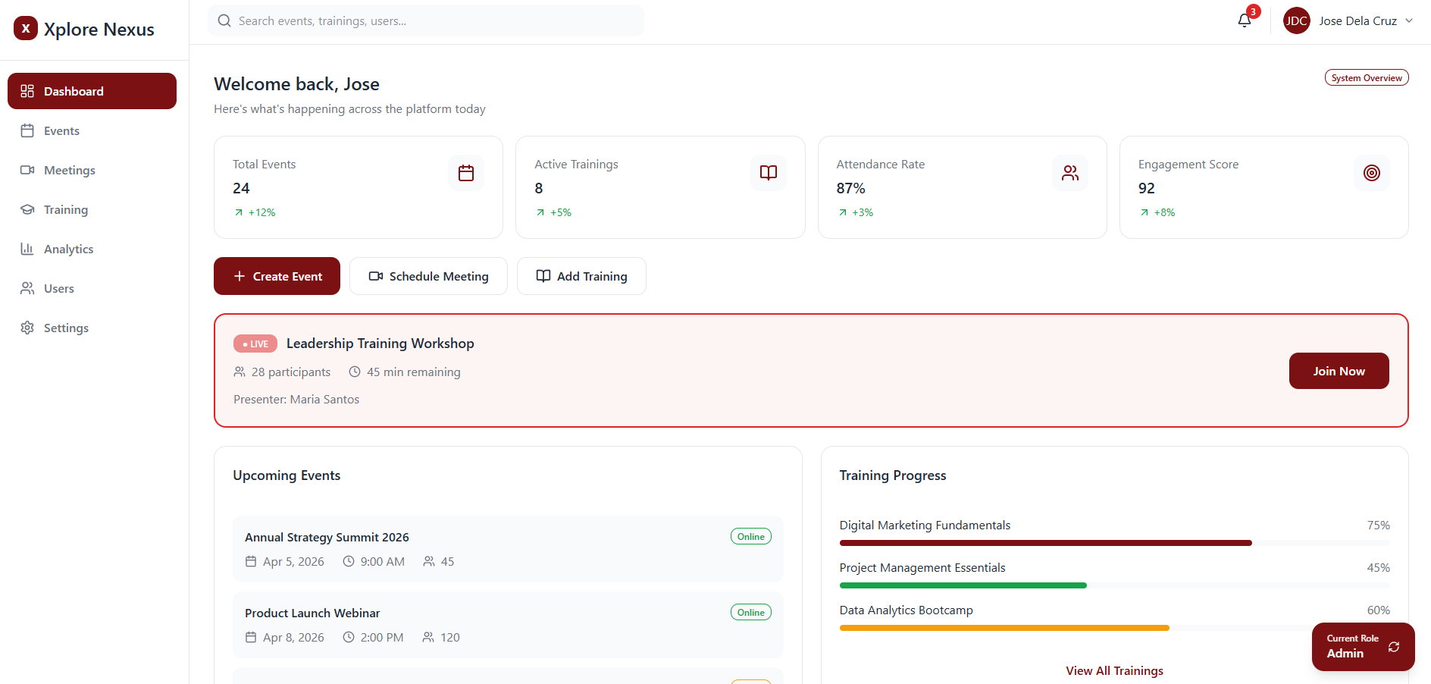

Dashboard Overview – Xplore Nexus
The dashboard serves as the central hub of the Xplore Nexus platform, providing users with a quick and organized view of system activities.
- At the top, users can see key metrics such as total events, active trainings, attendance rate, and engagement score, allowing quick performance monitoring.
- The navigation sidebar gives access to core modules including Events, Meetings, Training, Analytics, Users, and Settings.
- Users can quickly perform actions through buttons like Create Event, Schedule Meeting, and Add Training.
- A highlighted section shows live or ongoing sessions, enabling users to instantly join active events or trainings.
- The lower section displays upcoming events and training progress, helping users track schedules and personal development.

Overall, the dashboard is designed to provide real-time insights, quick actions, and seamless navigation within a single interface.

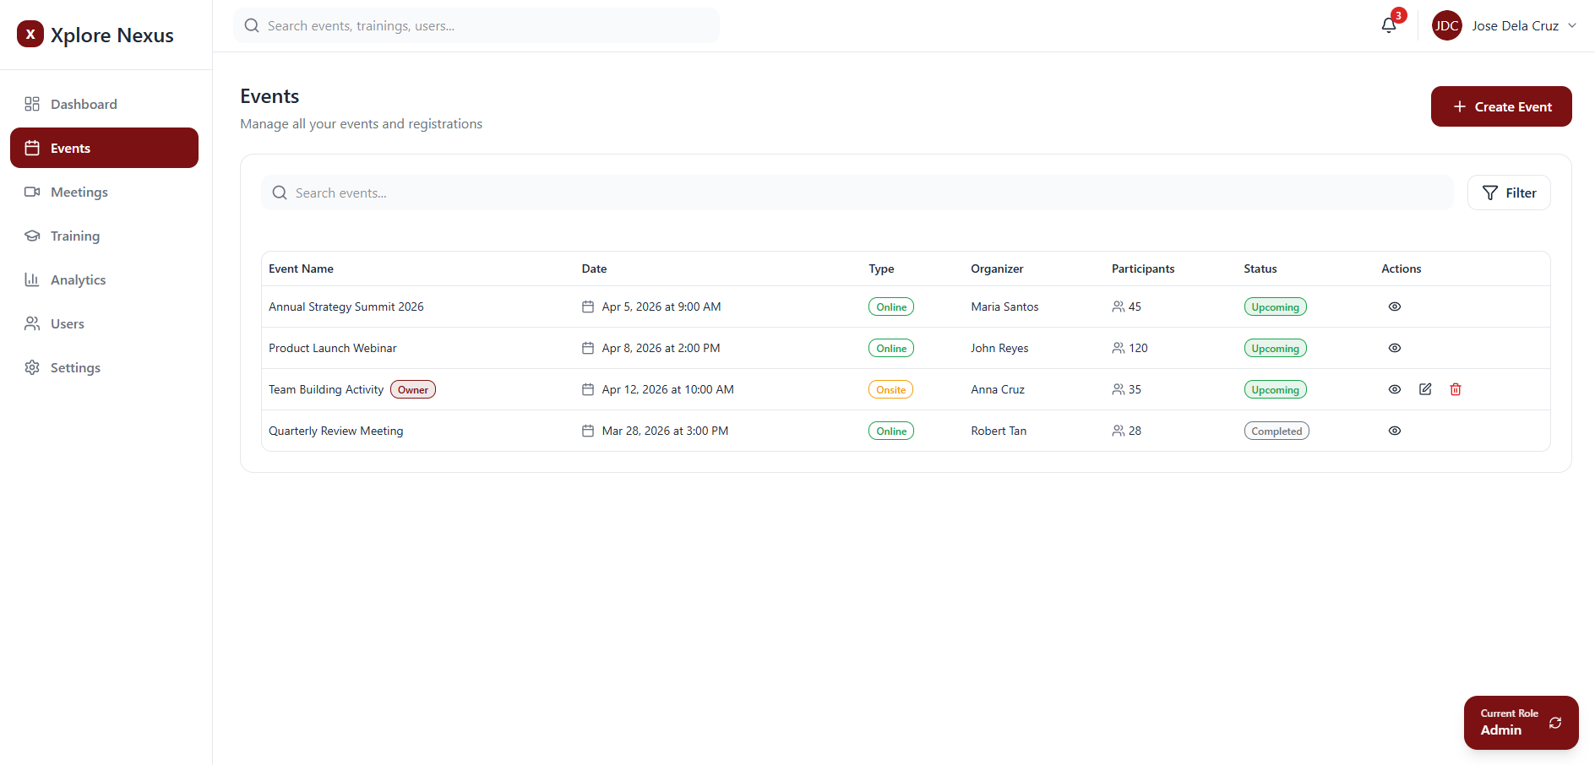

Events Management Module – Xplore Nexus
The Events module allows users to manage and monitor all events within the platform in a centralized view.
- It displays a list of events with key details such as event name, date, type (online/onsite), organizer, number of participants, and status (upcoming or completed).
- A search and filter function is available to quickly find specific events.
- Users can perform actions like viewing, editing, or deleting events, depending on their role.
- The “Create Event” button enables organizers or admins to easily schedule new events.
- Event ownership is also indicated, helping users identify events they manage.
Overall, this module provides an organized and efficient way to handle event scheduling, tracking, and management within the system.
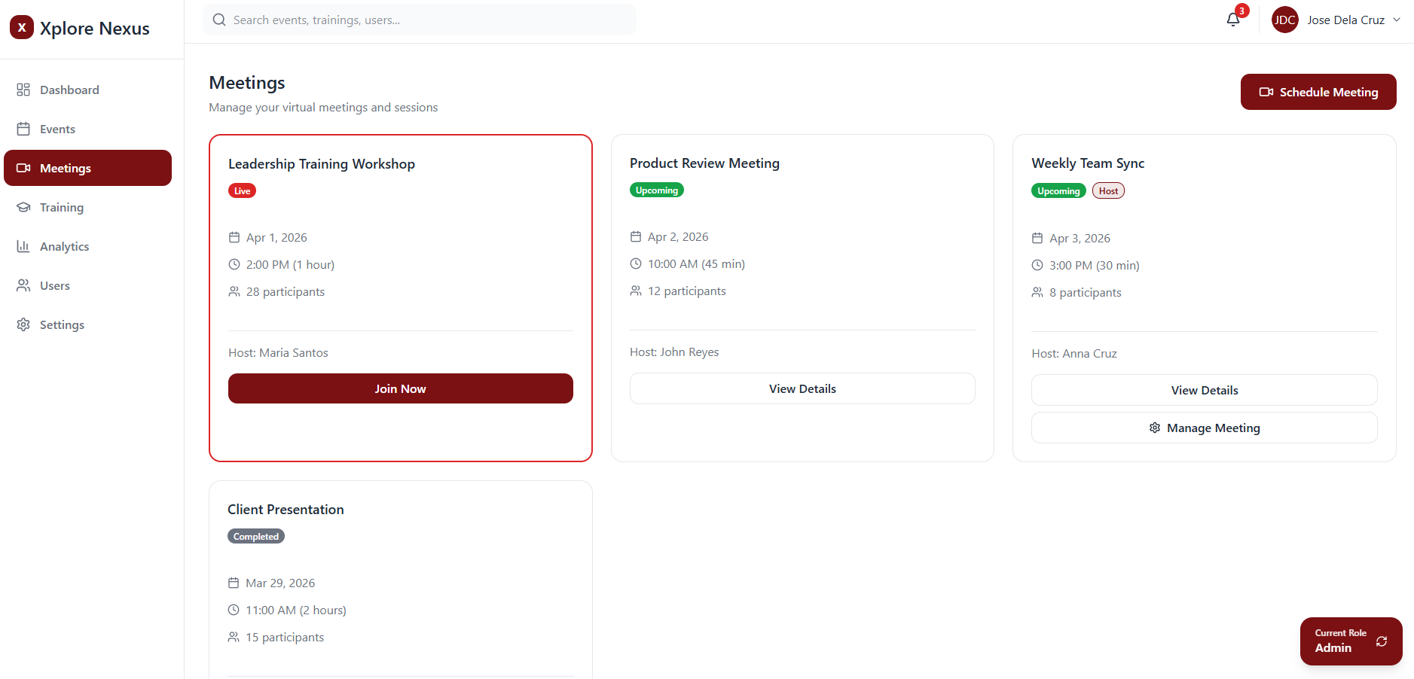

Meetings Module – Xplore Nexus
The Meetings module allows users to manage and access virtual meetings and sessions in a centralized interface.
- Meetings are displayed in card format, showing key details such as title, date, time, duration, host, and number of participants.
- Each meeting is labeled by status (Live, Upcoming, or Completed) for easy tracking.
- Users can quickly join active meetings through the “Join Now” button.
- Additional actions like viewing details or managing meetings are available depending on user roles.
- The “Schedule Meeting” button enables users to create and organize new sessions.
Overall, this module provides a clear and user-friendly way to handle meeting scheduling, participation, and management within the platform.
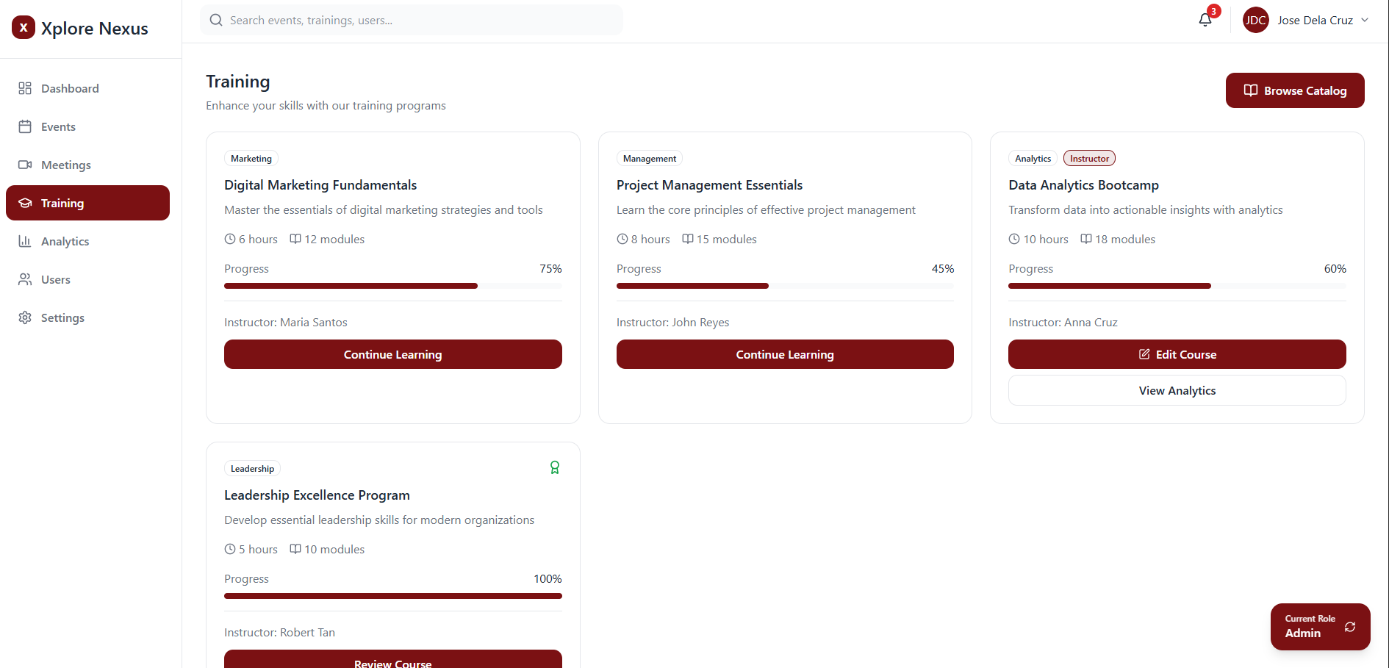

Training Module – Xplore Nexus
The Training module allows users to access, manage, and track learning programs within the platform.
- Trainings are presented in card format, displaying details such as course title, category, duration, number of modules, and instructor.
- Each training includes a progress bar, enabling users to monitor their completion status in real time.
- Users can continue their learning through the “Continue Learning” button or review completed courses.
- For users with higher permissions (e.g., instructors or admins), options like editing courses and viewing analytics are available.
- The “Browse Catalog” button allows users to explore additional training programs.
Overall, this module provides a structured and interactive learning experience, supporting skill development and progress tracking within a centralized system.

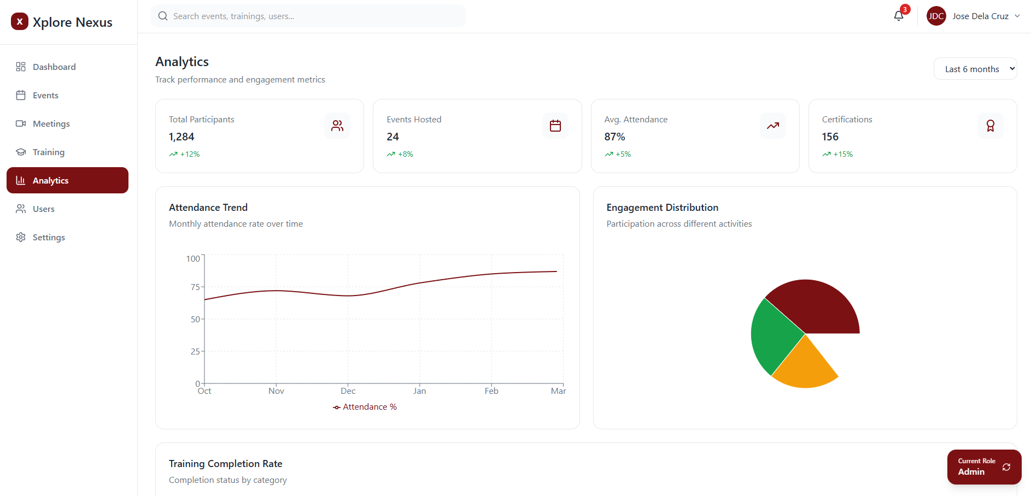

Analytics Module – Xplore Nexus
The Analytics module provides a centralized view of performance and engagement metrics across the platform.
- It displays key statistics such as total participants, events hosted, average attendance rate, and certifications issued, giving a quick overview of system performance.
- A line chart shows attendance trends over time, helping track participation patterns and improvements.
- A pie chart visualizes engagement distribution across different activities.
- Users can filter data (e.g., last 6 months) to analyze specific time periods.
Overall, this module enables data-driven insights and decision-making by presenting clear and actionable performance metrics.
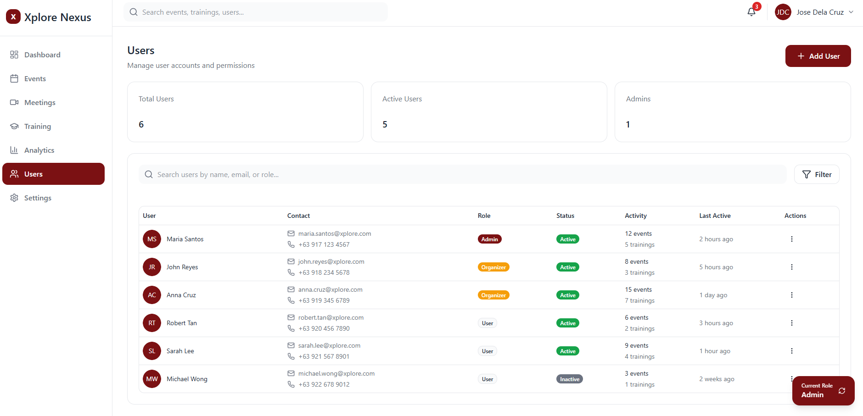

User Management Module – Xplore Nexus
The Users module allows administrators to manage user accounts, roles, and system access in a centralized interface.
- It provides an overview of total users, active users, and administrators for quick monitoring.
- A searchable table displays user details such as name, contact information, role, status, activity, and last active time.
- Roles (Admin, Organizer, User) and account status (Active/Inactive) are clearly indicated for easy management.
- Admins can perform actions like adding new users, editing details, assigning roles, or managing account status.
- The search and filter function helps quickly locate specific users.
Overall, this module ensures efficient user administration, access control, and system security within the platform.
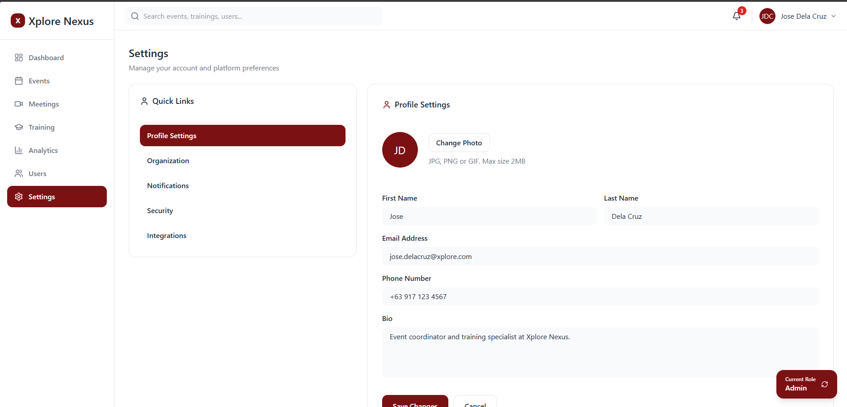

Settings Module – Xplore Nexus
The Settings module allows users to manage account details and platform preferences in a centralized interface.
- It includes sections such as Profile Settings, Organization, Notifications, Security, and Integrations for easy navigation.
- Users can update personal information like name, email, phone number, profile photo, and bio.
- The module supports customization of account settings and preferences based on user needs.
- Security and integration options ensure proper account protection and system connectivity.
Overall, this module provides a flexible and user-friendly way to manage personal and system settings within the platform.

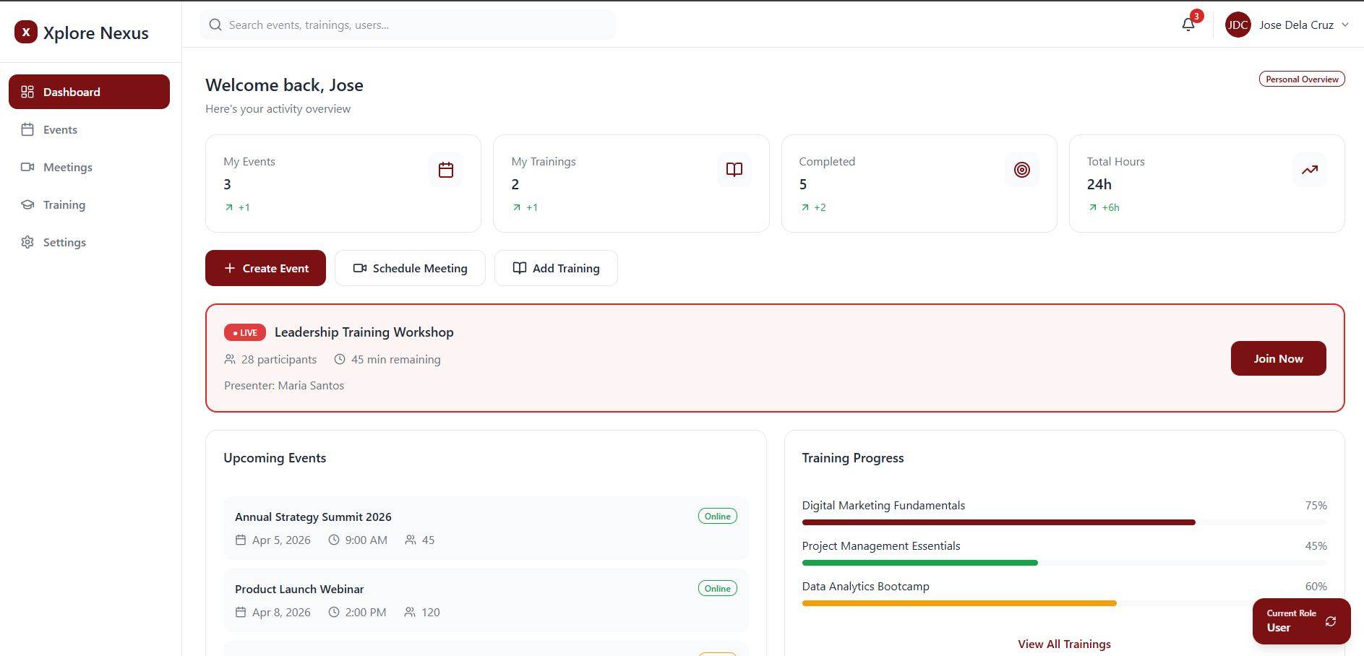

User View Interface – Xplore Nexus
The user interface presents a personalized dashboard view tailored for standard users.
- It highlights individual activity metrics such as events joined, trainings enrolled, completed sessions, and total hours.
- Users can easily access ongoing sessions and join live events directly from the dashboard.
- Sections like upcoming events and training progress help users stay informed and track their participation.
- Available actions are simplified to focus on joining, viewing, and learning, rather than managing system data.
The overall layout remains consistent with the admin interface; however, features and actions are limited based on user roles.
Other pages (Events, Meetings, Training, etc.) follow the same structure but are adjusted to user-level access, showing only relevant actions and permissions.

Appendix A — Glossary
The following terms are used throughout this document and the Xplore Nexus platform:
Term | Definition
Administrator (Admin) | A user role with full system access, including user management, role assignment, and system settings.
Organizer | A user role responsible for creating and managing events, meetings, and training programs.
Participant (User) | A standard user who can register for events, enroll in training, and join meetings.
RBAC | Role-Based Access Control — a security model that restricts system access based on assigned user roles.
JWT | JSON Web Token — a compact, URL-safe token format used for authentication and session management.
Live Session | An event or meeting that is currently in progress and available for users to join in real time.
Module | A single unit of content within a training program (e.g., a video lesson or quiz section).
Engagement Score | A composite metric reflecting user activity levels across events, meetings, and training on the platform.
Supabase | An open-source Firebase alternative providing PostgreSQL database, authentication, real-time subscriptions, and storage.
Zoom API | The Zoom Meeting SDK & REST API used to programmatically create and manage video meetings within the platform.
PayMongo | A Philippines-based payment gateway used for processing online payments within the platform.
Stripe | An international payment gateway used as an alternative to PayMongo for non-Philippine users.
SSR | Server-Side Rendering — a Next.js feature where pages are rendered on the server per request for improved SEO and performance.
RLS | Row-Level Security — a Supabase/PostgreSQL feature that enforces data access rules at the database query level.
CI/CD | Continuous Integration / Continuous Deployment — automated pipelines that build, test, and deploy code on each push.
WCAG | Web Content Accessibility Guidelines — international standards for making web interfaces accessible to users with disabilities.
MVP | Minimum Viable Product — the initial version of the product with only core functionality needed for launch.
Webhook | An HTTP callback triggered by an external service (e.g., PayMongo calls the platform's webhook URL upon payment confirmation).

